14 HOWA (THAILAND) CO., LTD.
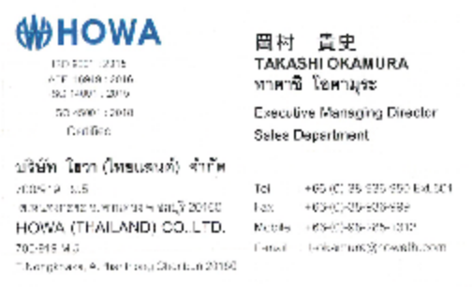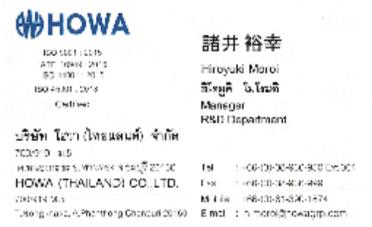
15 INOAC AUTOMOTIVE (THAILAND) CO., LTD.
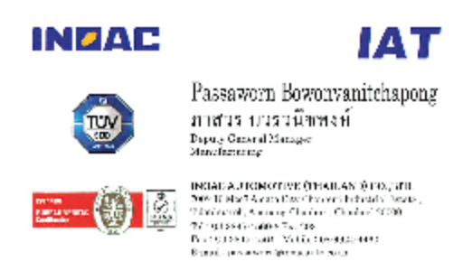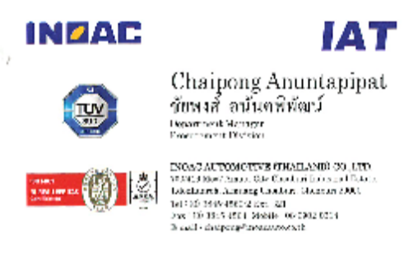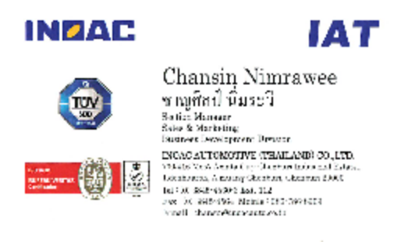

16 Thai Mitchi Corporation Ltd.
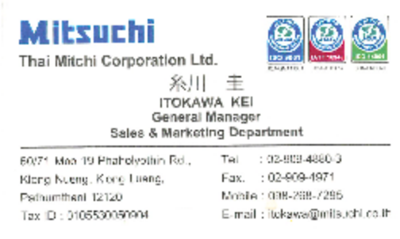

17 SIAM DAISO INDUSTRIES CO., LTD
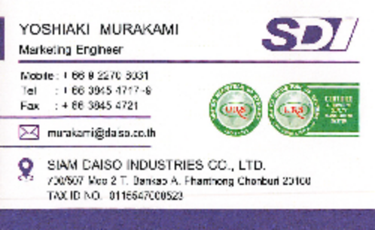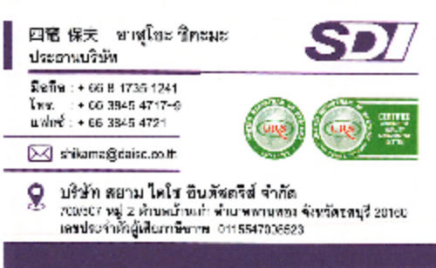
18 MEIWA INDUSTRY (THAILAND) CO., LTD.
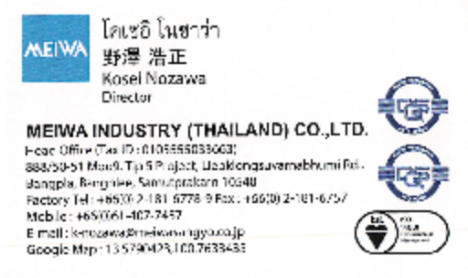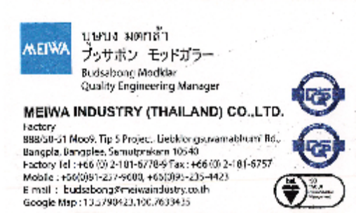
19 SIAMNAK TRADING CO., LTD.
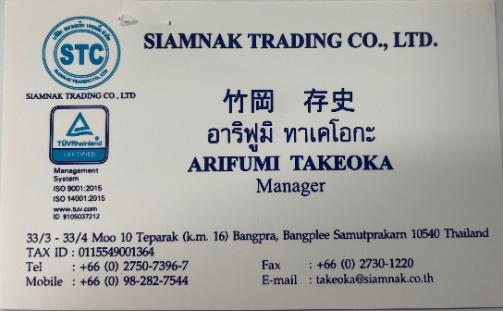
20 Sunstar Chemicl (Thailand) Co., Ltd.
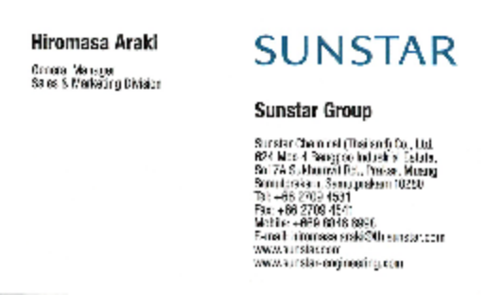

21 ㈱ イーズ
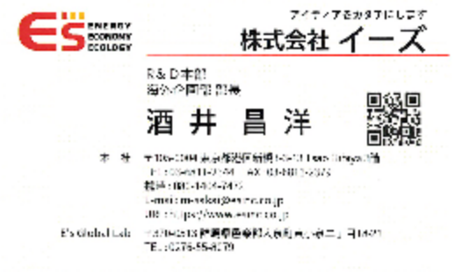
22 NIFCO (THAILAND) CO., LTD.
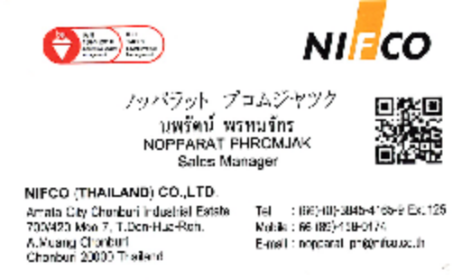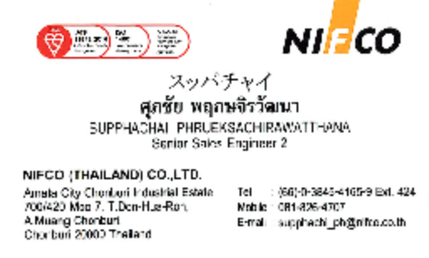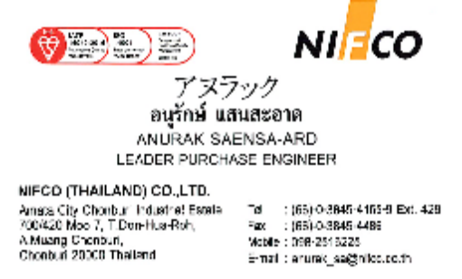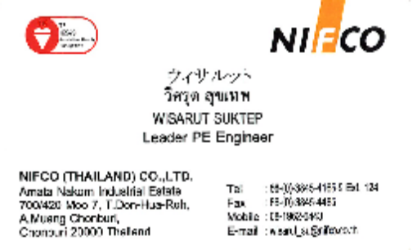

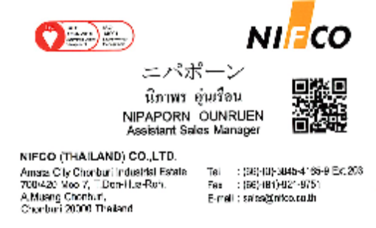

23 AISIN ASIA PACIFIC Co., Ltd
.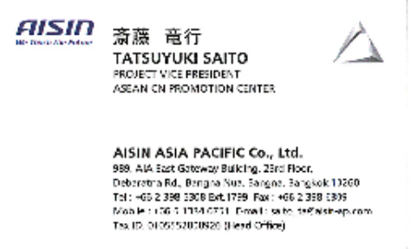

24 DEXTECH (THAILAND) Co., Ltd.
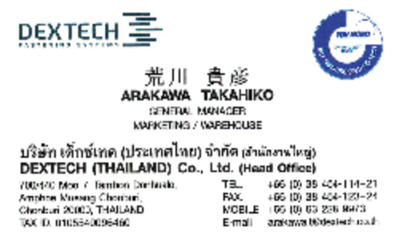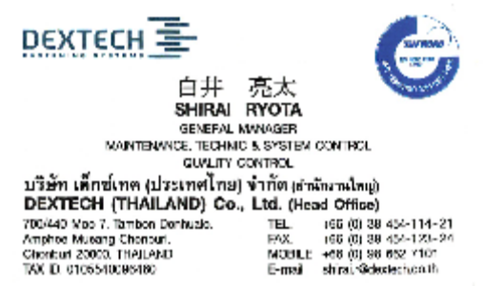
25 SIAM SENATER CO., LTD.
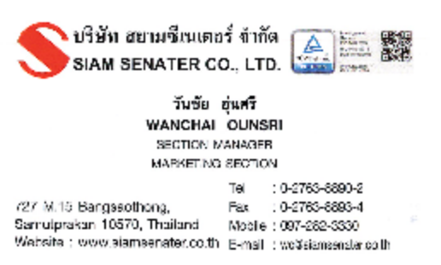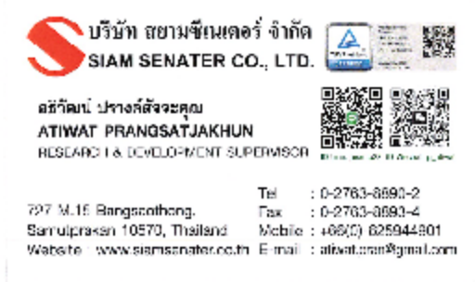
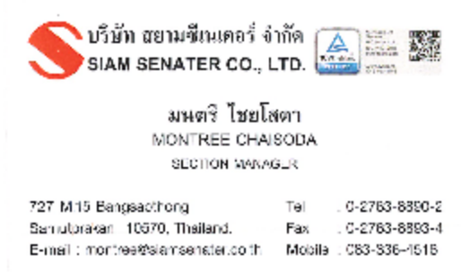

26 THAI FC-TEC CO., LTD.
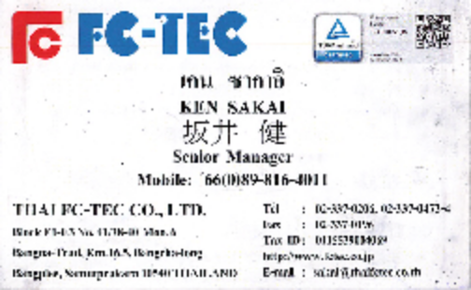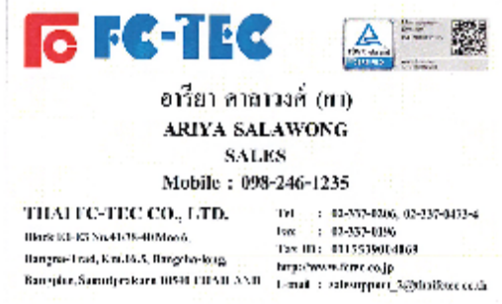
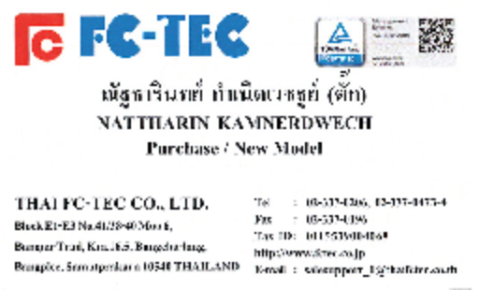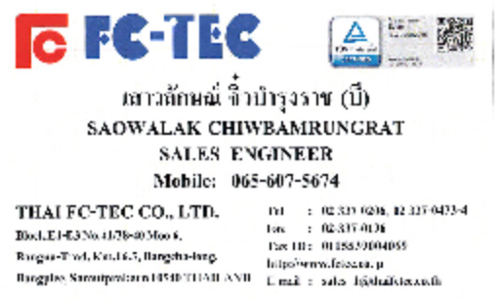
27 BANGKOK TAIYO SPRINGS CO., LTD.
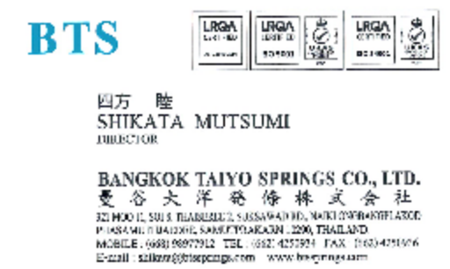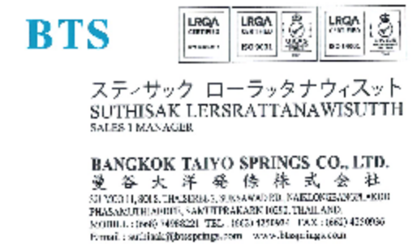
28 TOYOTA TSUSHO (THAILAND) CO., LTD.
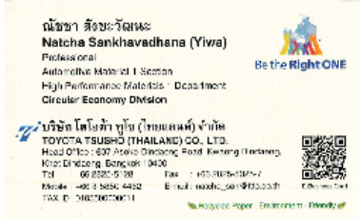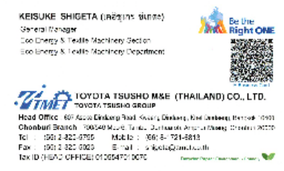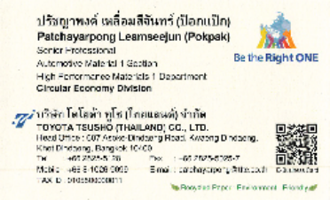
29 TYK FILTERS CO., LTD.
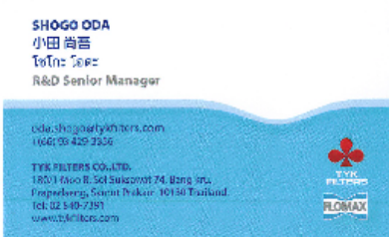
30 AMPAS INDUSTRIES CO., LTD.
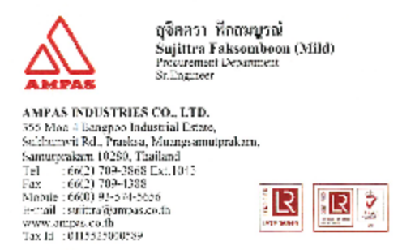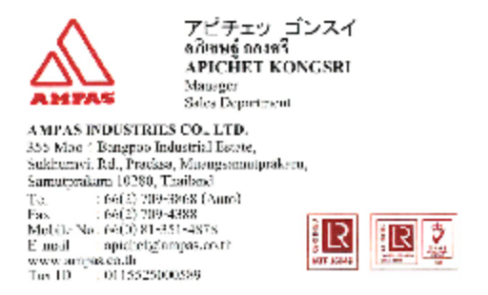
31 KOJIMA INDUSTRIES ASIA CORPORATIPN LTD.
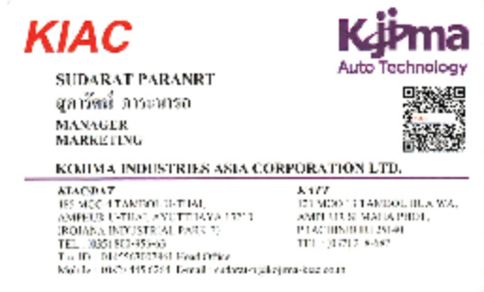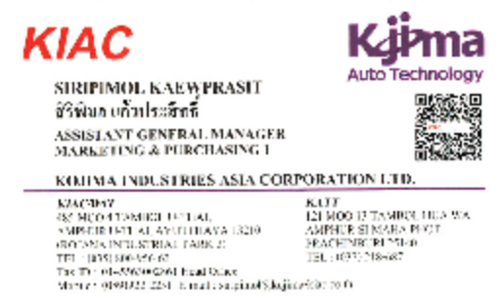
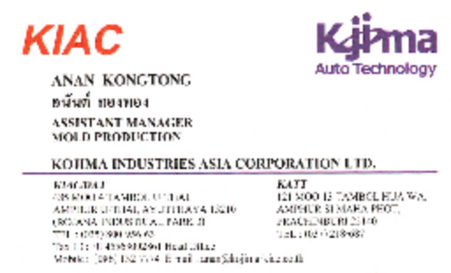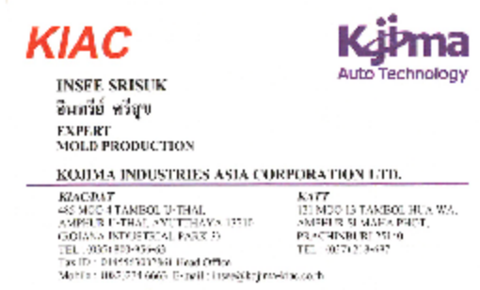

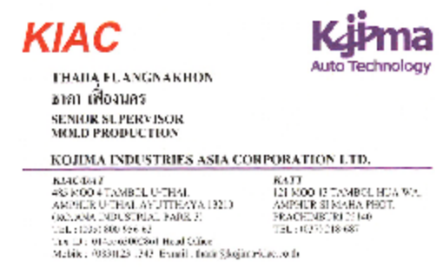

３２ TOKAI RIKA ASIA CO., LTD./TOKAI RIKA(THAILAND) CO.,LTD.
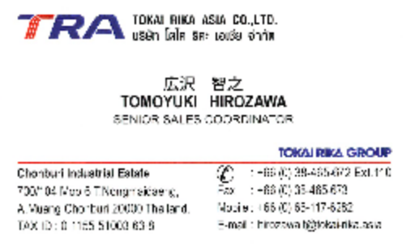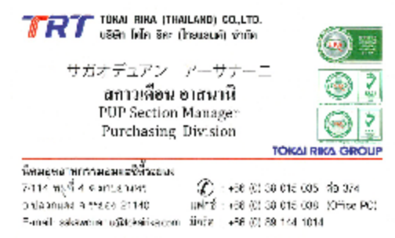
33 HAYASHI TELEMPU (THAILAND) CO., LTD.
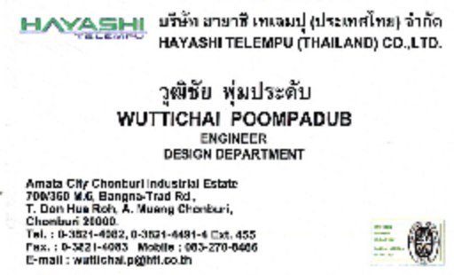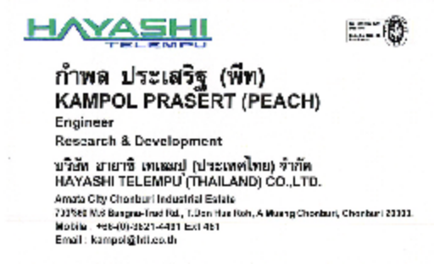
34 SIAM KENSETSU CO., LTD.
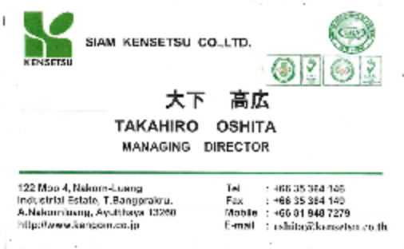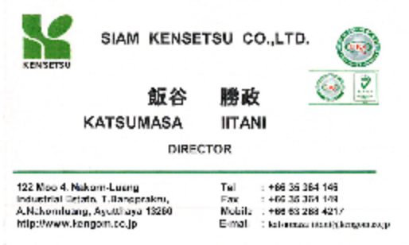
35 建設ゴム
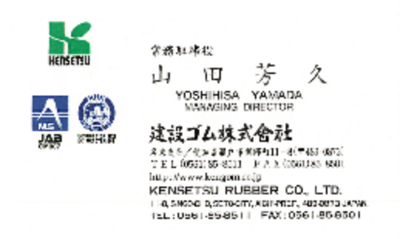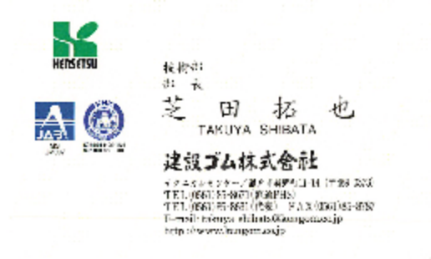

36 Sania (Thailand) Co., Ltd.
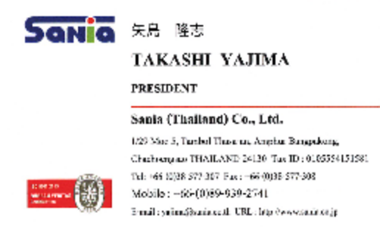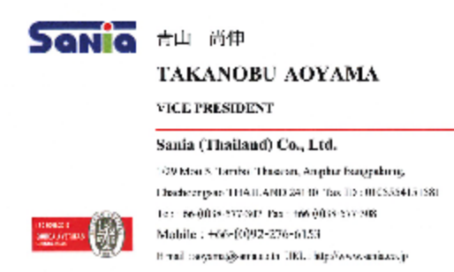
37 Feltol Manufacturing Co., Ltd.
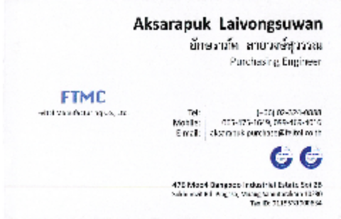
38 INABATA THAI CO., LTD.
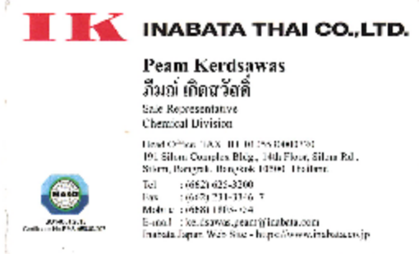
42 Saint-Gobain Sekurit (Thailand) Co.,Ltd.
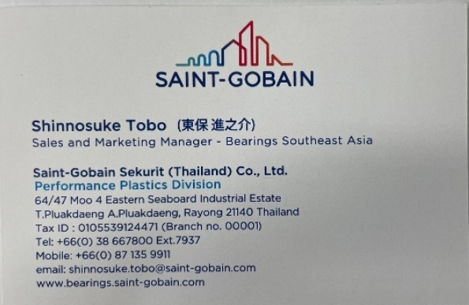

43 EQYO - Saint-Gobain
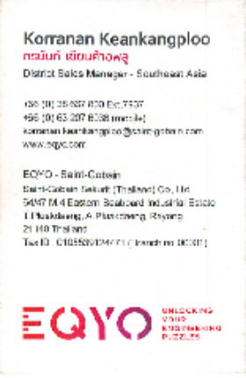
４４ TT Automotive Steel (Thailand) Co., Ltd.
Marketing 宮寺ひとみ
e-mail: miyadera@ttast.co.th
Tel: 095-627-9163
45 THAI SEAT BELT CO LTD
Project Management Ratchaneekorn
e-mail: ratchaneekorn@tsb.co.th
Tel: 090-132-5553
46 BVS MANUFACTURING CO., LTD.
Production Panadda Pukkarut
e-mail: panadda.pukkarut25@gmail.com
Tel: 062-529-5889
47 Aoyama Thai Co., Ltd. (ATC)
Sales Sapassara Dangbconnveng
e-mail: supassara-d@aoyama.co.th
Tel: 062-407-8406
48 Daiwa Fine Chemicals (THAILAND) Co., Ltd.
部門不明 Siripimol
e-mail: siripimol@kojima-kiac.co.th
Tel: 035-800956 261
49 KANAYAMA KASEI（THAILAND）
Sales Wanwisa Chartgin
e-mail: sales6@kanayama.co.th
Tel: 不明

